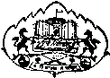
Savitribai Phule Pune University
Interdisciplinary School of Scientific Computing (ISSC)

Mid Semester Exam.- I August 2018

Course No. : SC - 104

Title : Foundation of Scientific Computing - II

Date : 17/08/2018
Time : 3:30 pm to 5:00 pm Marks : 30
______________________________________________________________________________

Note : The first question is compulsory, attempt any three of the remaining
questions.

Q.1. Attempt any six. (2 marks each.)

(i) Plot the graph of 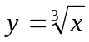 , 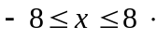

(ii) Evaluate the limit, 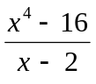 .
lim
x 2

(iii) Evaluate the limit, 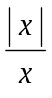 .
lim
x →∞ ∞

(iv) Is the function 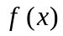 = 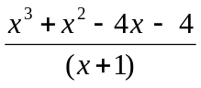 continuous at 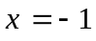 ? Justify your
answer.

(v) Find  if 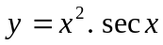
(vi) Find from the equation 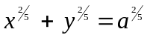.
(vii) Find if 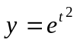and 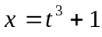
(viii) If 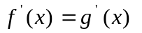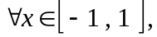can you say that 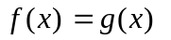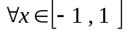?
Justify your answer.

(ix) Given 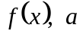 and 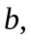 find by Lagrange’s Mean Value Theorem.
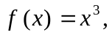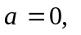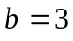

Q.2. Consider the function 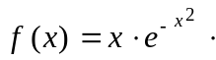

- Determine the regions in which the function is increasing , decreasing , concave (2)
up and concave down.

(ii) Locate and classify the critical points . Determine the points of inflection. (2)

(iii) Plot the graph of the function for − 2 ≤ x ≤ 2. (2)

Q.3 (a) The height of the rock, thrown vertically upwards on the surface of the moon, is given (2)
by 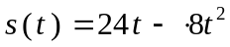 after seconds. How high will the rock go? How much time
will it take to reach half of its maximum height?
(b) Find the equation of the tangent lines to the curve 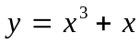 where slope is 4. (2)
(c) Find the values of and which make the following function differentiable at 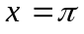 (2)
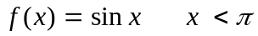
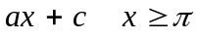
Q.4 (a) Find the dimensions of the rectangle of largest area that can be inscribed in a circle of (3)
radius units.

(b) A ladder of length 26 feet is rested against a vertical wall. The foot of the ladder is drawn (3)
away from the wall at the rate of 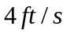. How fast is the area of the triangle formed by
the wall, ground level and ladder is changing when the foot is 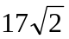 feet away from the
wall?

Q.5 (a) A right circular cone has altitude 6 feet and radius of base 6 ft. Another cone is inscribed (4)
in this cone in such a way that its vertex is at the center of the base of the original cone
and the bases of both the cones are parallel. Find the dimensions of the cone of maximum
volume that can be inscribed in such a way.

(b) Find two positive numbers whose sum is 36 and the product is as large as possible. (2)

*****

